LOAD BALANCER

* CREATE SECURITY GROUP

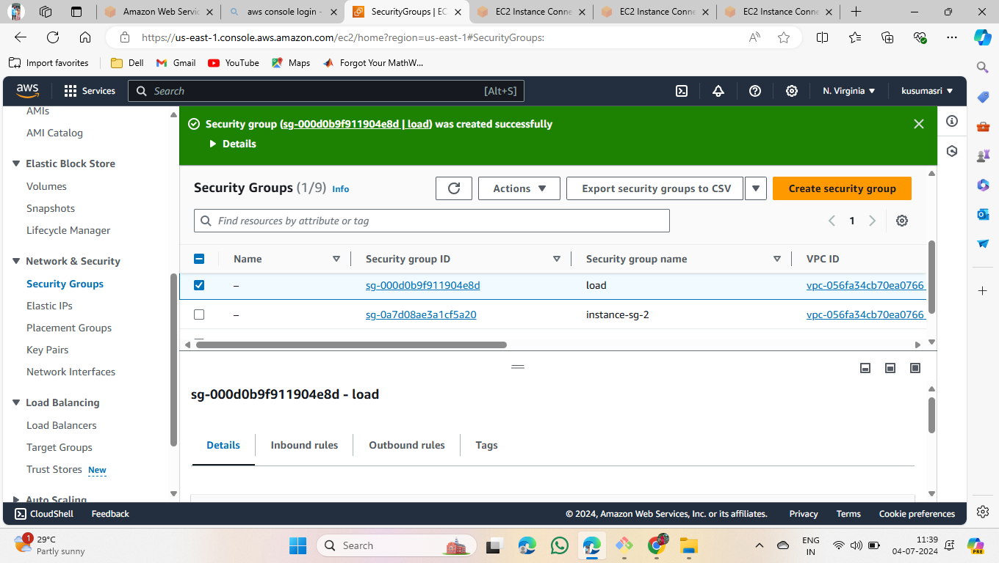

* CREATE 3 INSTANCES

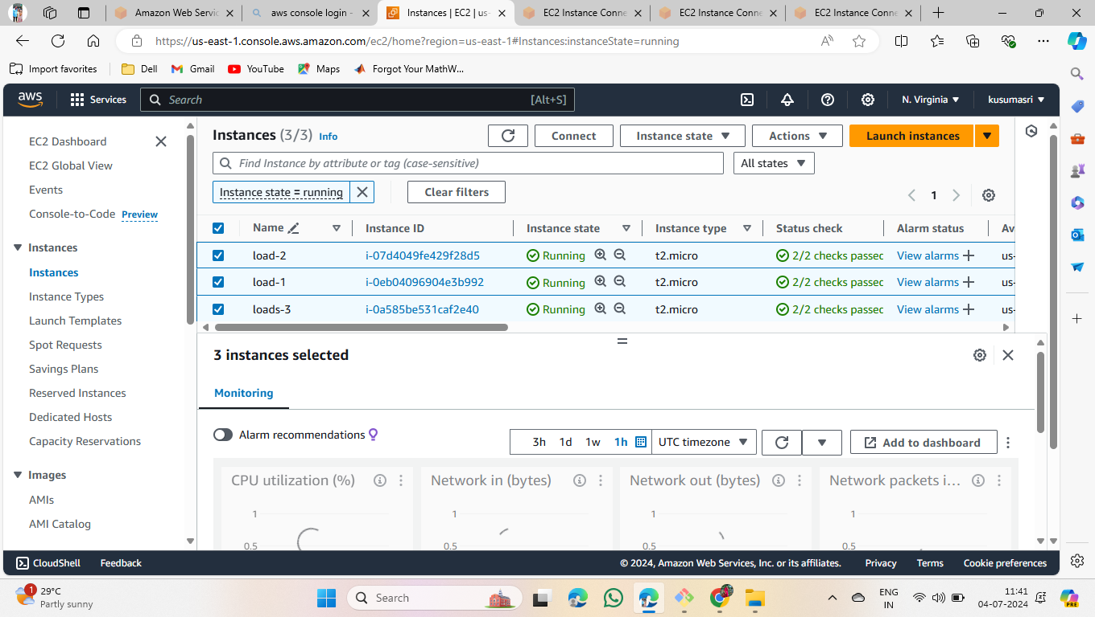

* CONNECT INSTANCE

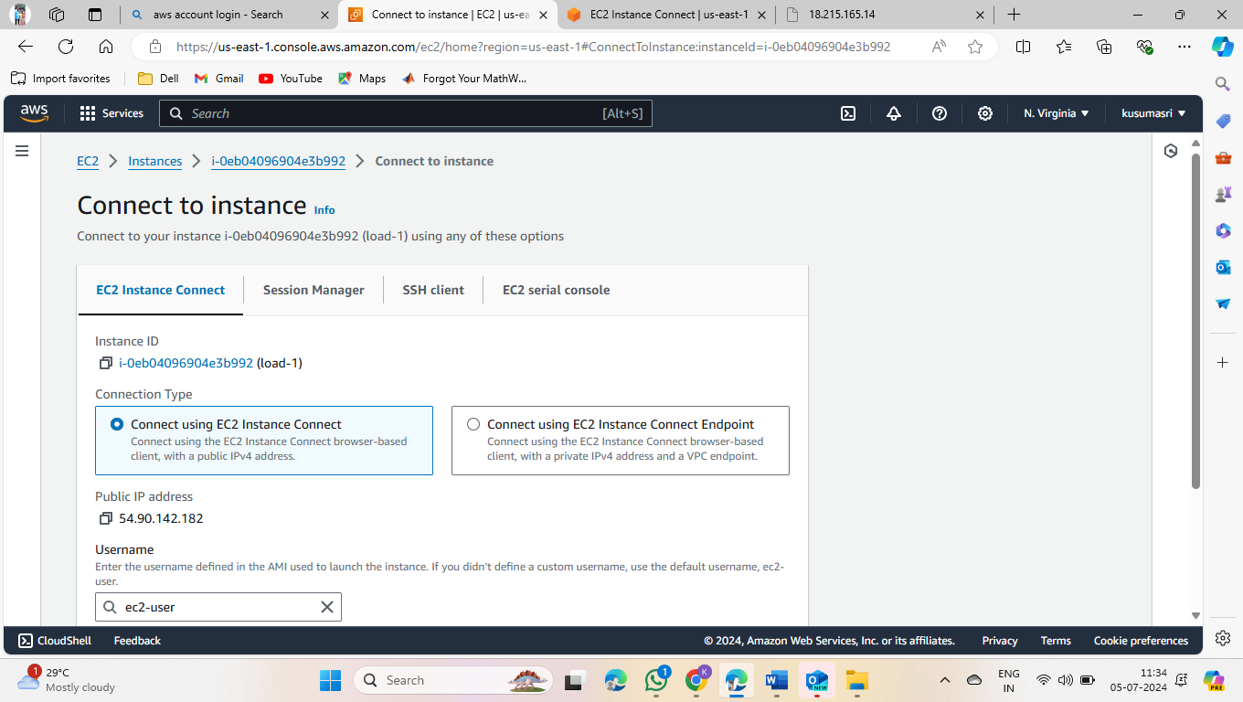

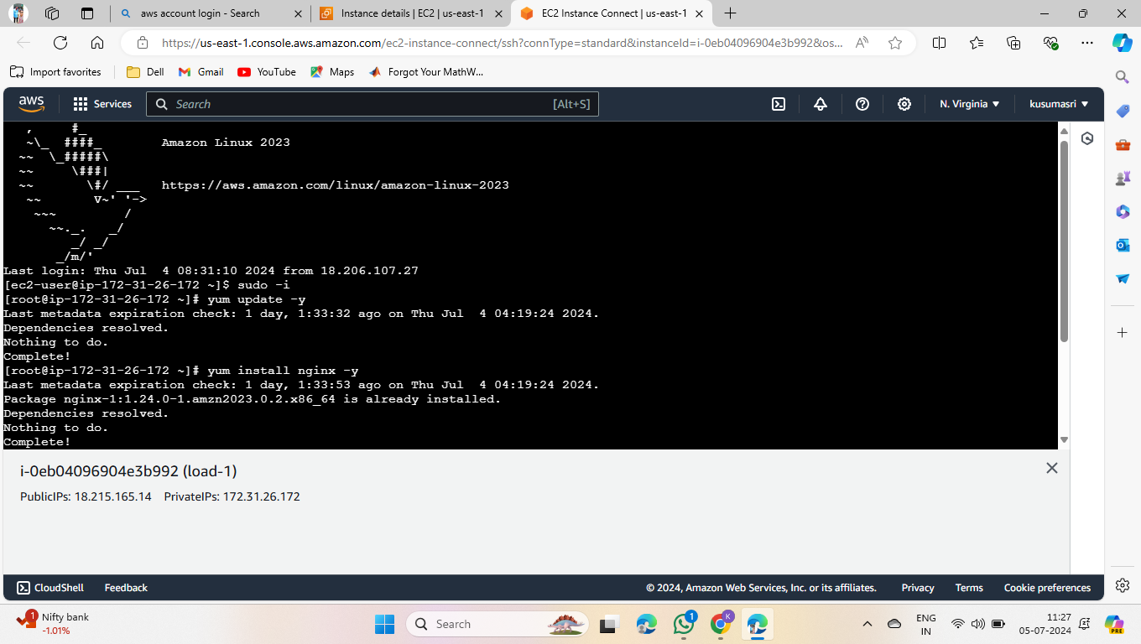

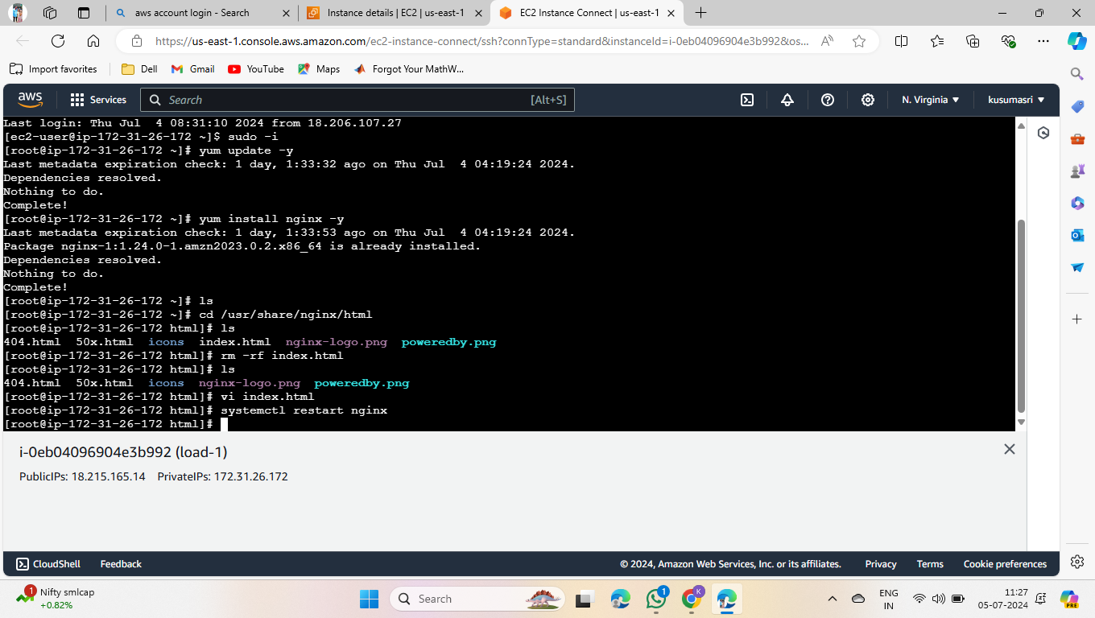

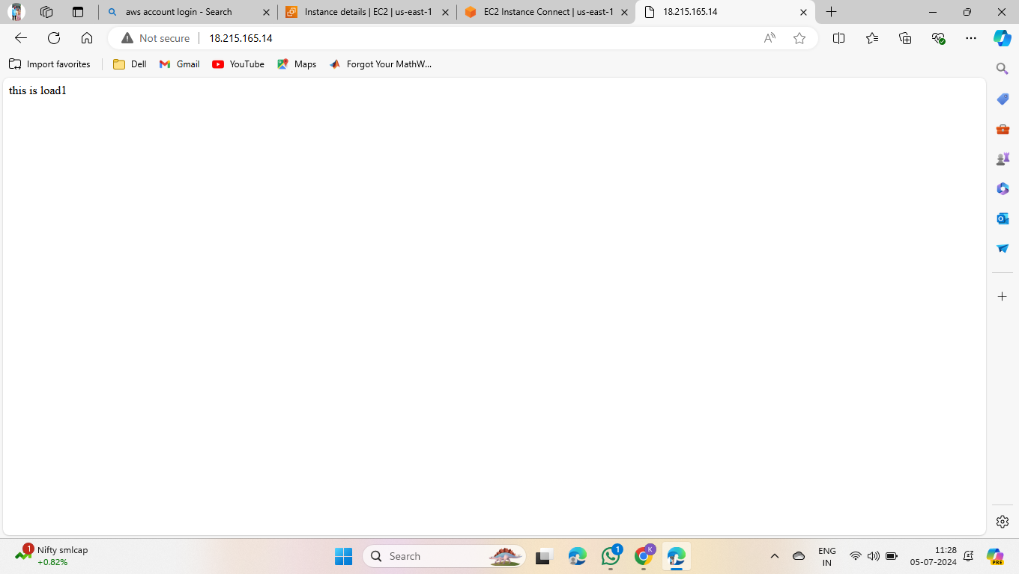

Similarly, load2 and load3 follows the same process as shown for load1.

* CREATE TARGET GROUP

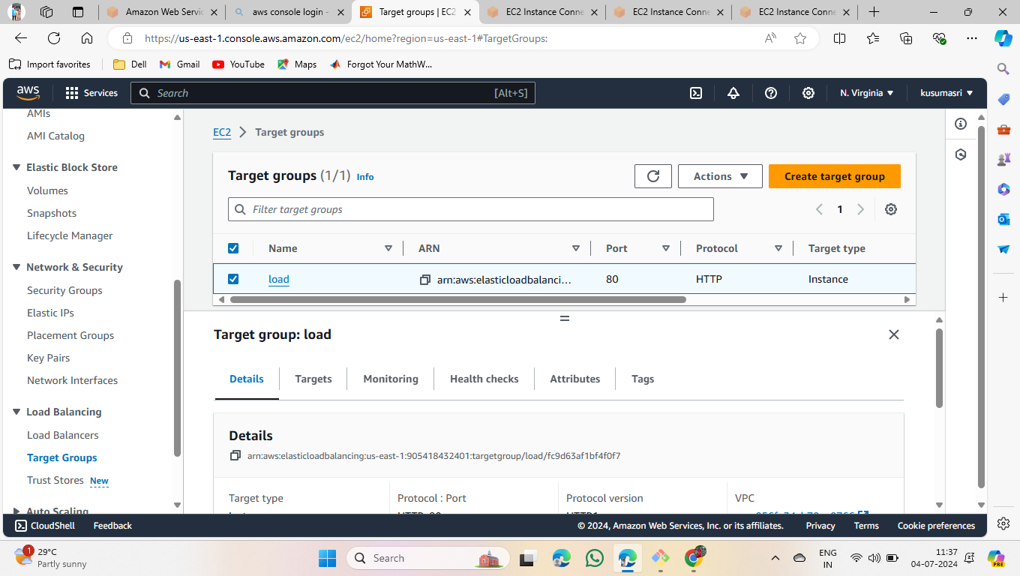

* CREATE LOAD BALANCER

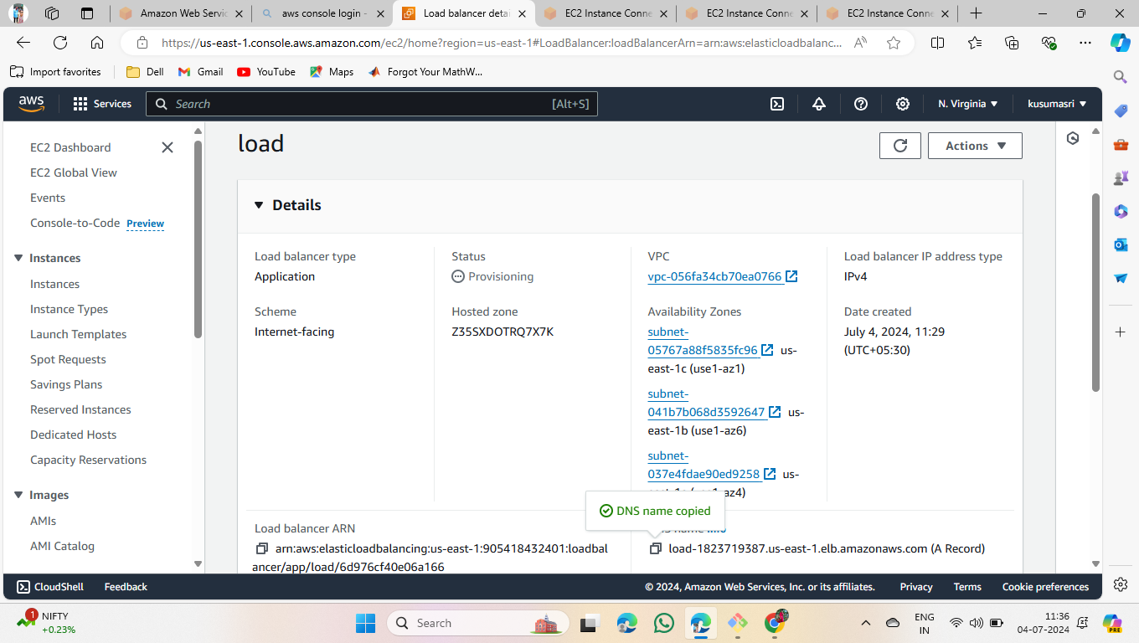

Copy and paste the DNS name in the web server and keep refreshing the page to get the text given in the instances.

